Logisim CPU Project
This project aims to design an 8-bit cpu and then implement it in logisim. Logism is a program that simulates basic digital logic components such as counters, registers, memory and logic gates. The point of this project is not to make a good cpu or to design a good instruction set but to learn about digital logic and to unserstand how basic logic components like registers, counters, logic gates and larger memory structures like RAM and ROM are put together to make a complex system like a CPU.

Specifications
- All buses and registers are 8-bits wide.
- Harvard architecture. So program and data memory are separate.
- 256 bytes of instruction memory and 32 bytes of data memory.
- Uses a microprogrammed control unit.
- Has an Accumalator based architecture.

The instruction format of the CPU is as follows.
3 bits for opcode | 5-bits for address of operand

Since only five bits are available for the operand address the data memory is only 32-bytes.
The instruction set of the computer contains only 8 instructions which are given below with their opcodes and function.
ADD address | 000 | Acc <= Acc + [addr]
STR address | 001 | [Addr] <= Acc
SUB address | 010 | Acc <= Acc – [addr]
INC | 011 | Acc <= Acc + 1
B | 100 | Pc <= Acc
AND | 101 | Acc <= Acc & [Addr]
OR | 110 | Acc <= Acc | [Addr]
CMP | 111 | Acc <= Acc’

Architecture
This cpu contains two parts the fetch datapath and the instruction datapath. The fetch datapath is responsible for taking the instruction from the instruction memory and putting it in the instruction register, while the instruction datapath is responsible for executing the instruction that is there in the instruction register. Both of these datapaths have separate control signals associated with them and are controlled by different control memories called the fetch control memory and the instruction control memory. The PC and the IR act as a bridge between the two datapaths. The two control memories are controlled by the sequencer.
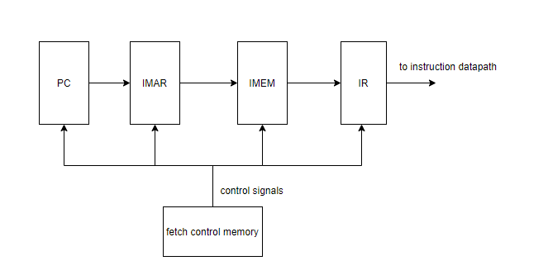
Fetch datapath

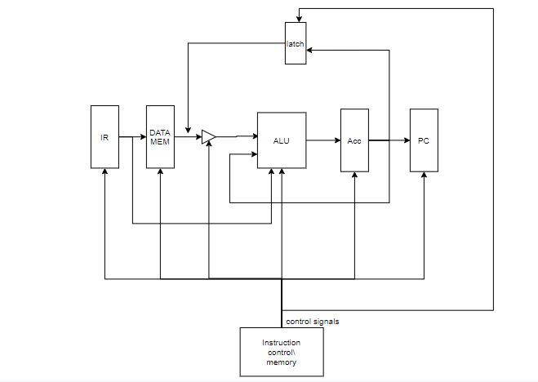
Instruction datapath
Internal logisim diagrams
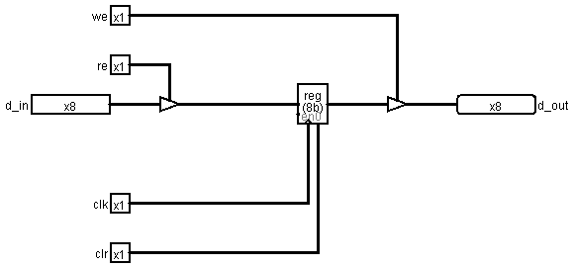
Registers
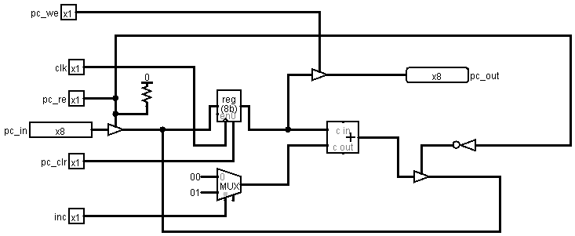
PC
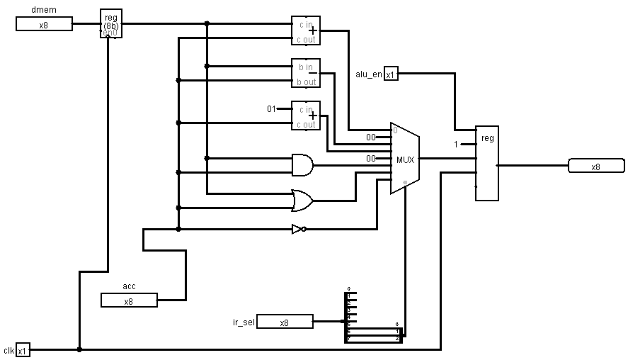
ALU

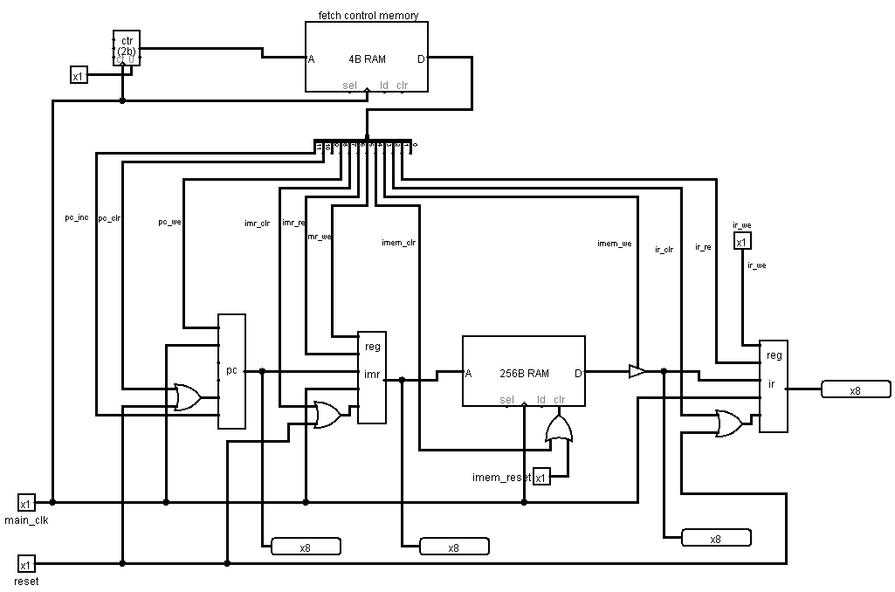
Fetch datapatch

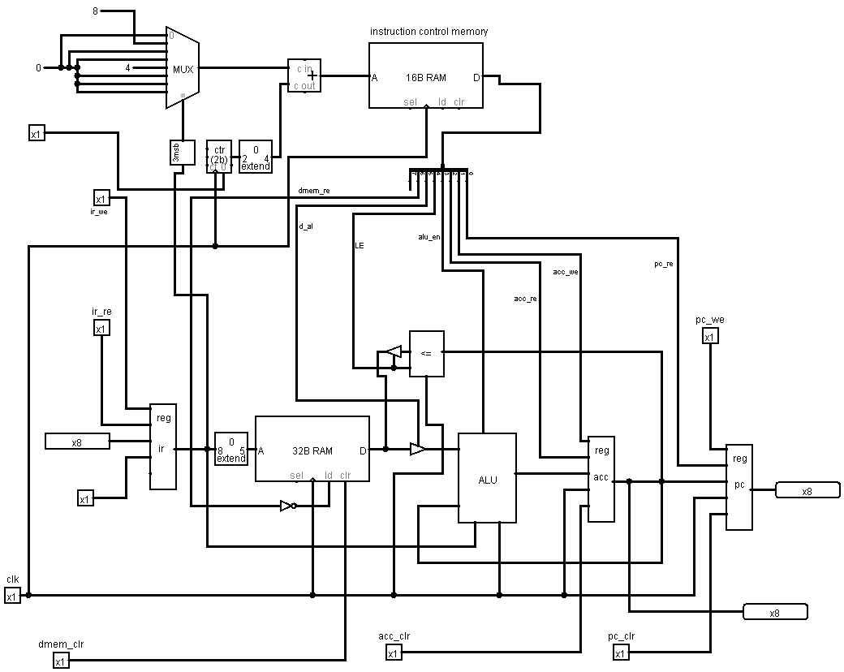
Insturction datapath
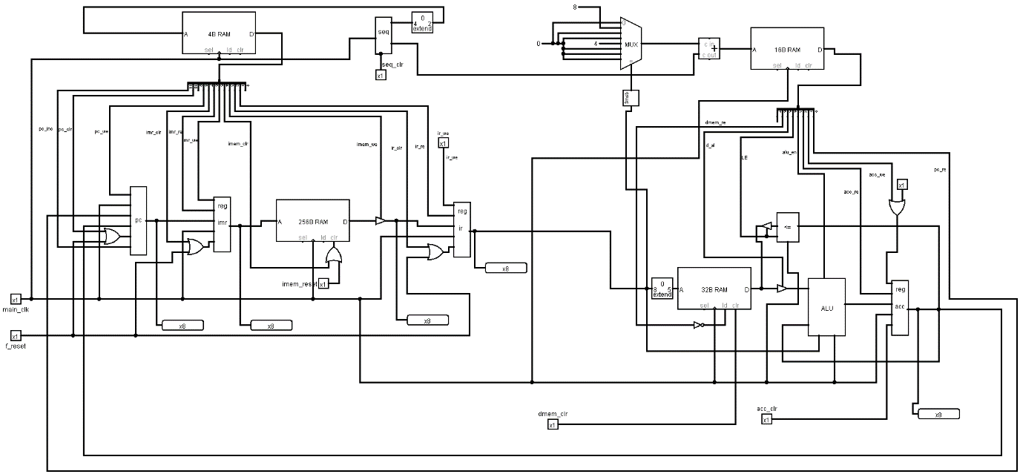
Entire CPU

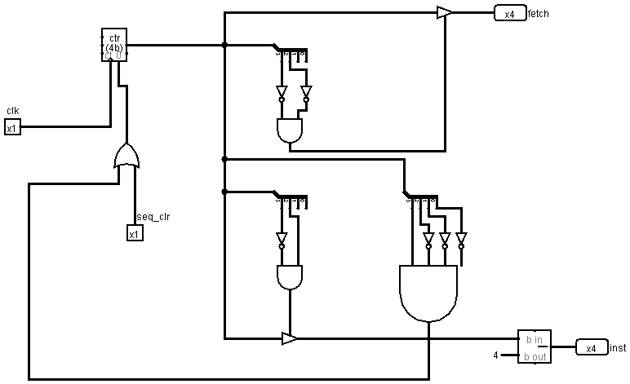
Sequencer

Control unit Architecture
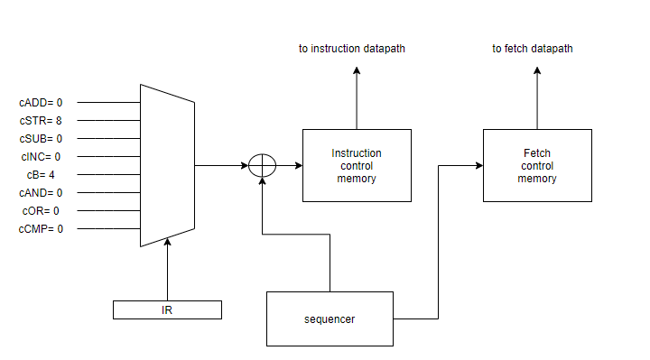
Control unit architecture
Fetch cycle contains the following steps,
- IMAR <= PC
- PC <= Pc + 1
- IR <= IMEM[IMAR]
The control signals corresponding to the above steps have to be sent by the fetch control memory. The following are the control signals for the fetch datapath and their values at each timestep to do the steps in the fetch cycle.
Pc_inc | Pc_clr | Pc_re (d) | Pc_we | Imar_clr | Imr_re | Imr_we | Imem_clr | Imem_we | Ir_clr | Ir_re | Ir_we | Hex val
0 | 0 | 0 | 1 | 0 | 1 | 1 | 0 | 0 | 0 | 0 | 0 | 0x140
1 | 0 | 0 | 0 | 0 | 0 | 1 | 0 | 1 | 0 | 0 | 0 | 0x828
0 | 0 | 0 | 0 | 0 | 0 | 1 | 0 | 1 | 0 | 1 | 0 | 0x2a
0 | 0 | 0 | 0 | 0 | 0 | 1 | 0 | 0 | 0 | 0 | 0 | 0x0

Instruction control signals
ir_we | dmem_re | d_al | LE | alu_en | acc_re | acc_we | pc_re |  | bin | hex
1 | 0 | 1 | 0 | 0 | 0 | 0 | 0 | alu | 10100000 | 0xa0
1 | 0 | 0 | 0 | 1 | 0 | 1 | 0 |  | 10001010 | 0x8a
1 | 0 | 0 | 0 | 1 | 1 | 0 | 0 |  | 10001100 | 0x8c
0 | 0 | 0 | 0 | 0 | 0 | 0 | 0 |  | 00000000 | 0x0
1 | 0 | 0 | 0 | 0 | 0 | 1 | 0 | b | 10000010 | 0x82
1 | 0 | 0 | 0 | 0 | 0 | 1 | 1 |  | 10000011 | 0x83
1 | 0 | 0 | 0 | 0 | 0 | 0 | 0 |  | 10000000 | 0x80
0 | 0 | 0 | 0 | 0 | 0 | 0 | 0 |  | 00000000 | 0x0
1 | 1 | 0 | 1 | 0 | 0 | 1 | 0 | str | 11010010 | 0xd2
1 | 1 | 0 | 1 | 0 | 0 | 1 | 0 |  | 11010010 | 0xd2
1 | 0 | 0 | 0 | 0 | 0 | 0 | 0 |  | 10000000 | 0x80
0 | 0 | 0 | 0 | 0 | 0 | 0 | 0 |  | 00000000 | 0x0

